https://www.technlg.net/windows/recent-documents-missing-in-windows-7/:
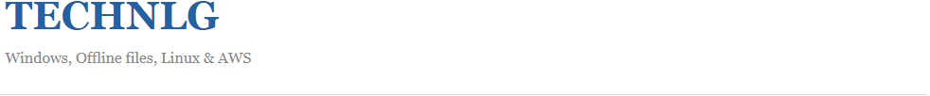
Recent Documents missing in Start Menu in Windows 7 (technlg.net)
on FEBRUARY 7, 2010
Contents
Group Policy configuration for Recent Items: 3
In Windows 7 clear recent items button is missing in start menu properties. How to clear Recent Items list then? 4
How to enable/disable recent items link using registry keys? 4

If you don’t see Recent Items list in Windows 7 start menu, you can add it by doing the following steps.
- Right click on the Start button. Select Properties.
- Click on the Start Menu tab in Taksbar and Start Menu Properties window
- Click on Customize button.
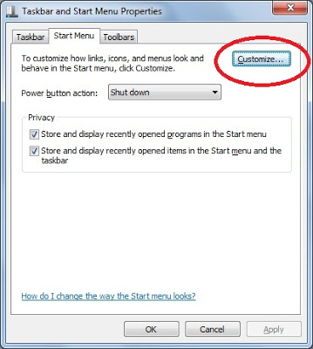
- In the customize start menu window select the check box ‘Recent Items’
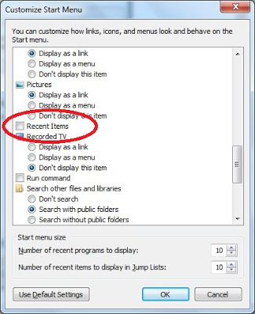
- Click OK button. Now you are in Start menu tab.
- The above step only adds Recent Items link to the start menu. But you can see items added to the list only if the second check button in the Start menu tab (i.e ‘Store and display recently opened items in the Start menu and the taskbar’ )is selected.
- Click on Apply and close the window.

Group Policy configuration for Recent Items:
Note: The below group policy settings are applicable for a Windows 7 system.
Recent Items list can be added to/deleted from start menu by configuring the group policy ‘Remove recent items menu from Start Menu’. This policy setting can be found under the node ‘User Configuration -> Administrative templates -> Start Menu and Taskbar‘
There is another related setting called ‘Do not keep history of recently opened documents‘. This one enables/disables the tracking of recently opened documents where as the above setting controls whether the list should be shown in the Start menu or not.
If you want to see the list of recent items from start menu, then you need to leave these two setting either in disabled or not configured state. If you enable the first one but disable/do not configure the second one there will not be any recent items in Start menu though the recently opened documents list is being saved. Conversely, if you disable/not configure the first setting and enable the second setting, Start menu shows the link to recent items but the list will be either empty or it shows the list of documents opened before enabling the second setting.

In Windows 7 clear recent items button is missing in start menu properties. How to clear Recent Items list then?
In Start menu, right click on Recent Items link. Click on ‘Clear Recent items list‘. In Windows XP, this option is present in start menu properties.

How to enable/disable recent items link using registry keys?
The registry key Start_ShowRecentDocs under the node HKEY_CURRENT_USERSoftwareMicrosoftWindowsCurrentVersionExplorerAdvanced controls the recent documents behavior. Setting this registry key to 0 removes the link from Start menu. Setting it to 1 adds a link and Setting it to 2 adds a menu with list of the documents.

